Best Practices Summit
Registration

Complete registration form and return to:

Via mail: | Work Ready Communities | Via e-mail to: workready@ky.gov
 | Attn: Elizabeth Hack  500 Mero Street, 3rd Floor | (Please save form and attach to email)
 | Frankfort, KY 40601

Contact Information:
Deadline for registration (limited to 150 registrants) is: April 24, 2015

- Dr.  Mr. Ms.  Mrs. First Name: Last Name: Address: City: State: Zip: County: Email: Daytime Phone:
Your County Affiliation:
  - Economic Development  Elected Official
  - Education  Business & Industry
  - Workforce Development
Your Organization: Your Title :

Your Local Workforce Investment Area:

- Barren River | - Bluegrass | - Cumberland’s
- EKCEP | - Greater Louisville | - Green River
- Lincoln Trail | - Northern Kentucky | - TENCO
- West Kentucky | - Not Sure

Work Ready Communities Status:
  - Kentucky Work Ready Community
  - Kentucky Work Ready Community in Progress
  - Letter of Intent submitted
  - County is Interested, but not currently working on application
# attending Best Practices Summit from your county (if known):
Note- Each attendee needs to complete and submit a registration form.

Should you have any questions on the Best Practices Summit or the Kentucky Work Ready Communities program please contact us at: workready@ky.gov or 502-564-0372

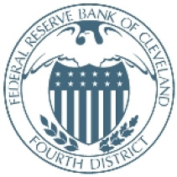
SUMMIT SPONSOR:

